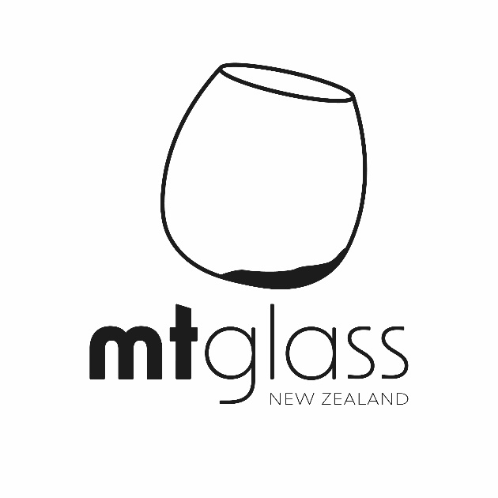
Try Sake - Learn Sake - Love Sake

Trade
New season Sake 2023

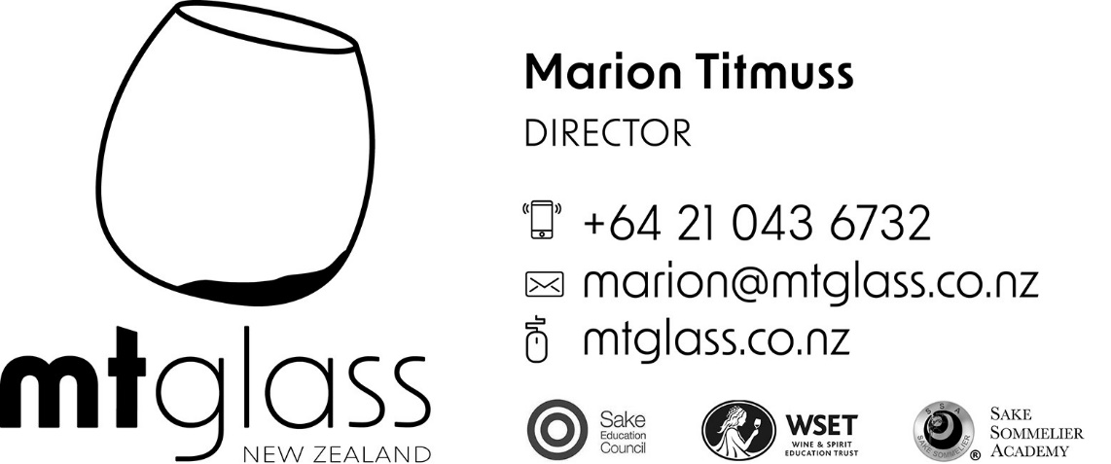
SERVICES
Events
Motivate your staff or reward your customers with a sake tasting. We offer packages from the light-hearted, fun and entertaining through to the more serious event for the seasoned wine buff or your staff who want to learn more about sake.
Cellar planning & En Primeur Advice
Thinking of starting a sake cellar? Not sure how to get the “fresh” stuff direct from those rare artisan breweries? Ask for advice from us for the best sake to drink to match your cuisine and which will offer the best return for financial gain.
Sake Sommelier Academy (London) and Sake Education Council (Japan) plus WSET trained staff
Marion holds accreditation from the SSA as a Sake Sommelier and Educator in addition to the Sake Education Council Sake qualifications. She also holds Level 3 Advanced Wine and Spirits and is studying for the Diploma. (the worldwide standard for wine education) plus in addition has a Post Graduate Qualification from EIT in Wine Technology, Business and Innovation.
Wedding consultations
Take advantage of our free friendly advice for all your wedding’s sake needs. Chat and taste informally with us for guidance on what really works on the day.
Mixology advice
Why Sake cocktails are all the rage internationally and why you should be featuring them right now!
Free local delivery
Free, safe delivery within 30 kms radius of Greytown.
Online Purchasing
Buy your favourite sake on our web shop – easy, secure and convenient.
Gain Qualifications – CERTIFIED SSA SOMMELIER QUALIFICATION
The SSA course is the only official Certified Sake Sommelier ® qualification in the world, your certificate will be stamped and provided by the London Sake Sommelier Academy.
Somm-Sake are the only accredited Sake Educator in NZ Sake Sommelier Academy® | New Zealand – Wellington – Sake Sommelier Academy®

Sake Library
STORAGE: Store in a dry and cool place. Avoid direct sunlight. Serve chilled (8-12 ºC)
We can supply Sparkling, low alcohol, fruit infused and rare & speciality Sake, please ask us for our Trade price list.
Why Sake - Why Now and why MT Glass?
The Sake market is still globally dominated by the well-known mass-manufactured brands but as consumers are becoming globally more Sake sophisticated, they are expected to seek out smaller artisan brands: in trend with overall alcohol beverage market. At present, around 70%–80% of the Sake produced is non-premium or low priced Futsushu and NZ has been importing this and trying (unsuccessfully) to sell it; growth is expected to occur more in the premium range (Ginjo and Daiginjo): again, in line with the overall alcohol beverage market as the Sake is a better match to kiwi palates used to high quality wine and gin.
MT Glass offers a point of difference and can supply higher-end, rarer Sake as well as advise on sourcing lower cost sake if required. As Sake becomes more mainstream, the demand is changing as consumers are becoming more sophisticated and are seeking out new, interesting Sake to drink that is in tune with global trends. Non-mass-produced Sake with brand stories allows you to attract new consumers and have a differentiated sales points over other bars and restaurants.
In Australia the Sake import market was the second fastest growing market globally with total Sake imports up 13 per cent to about $5.7 million.
In comparison to wine and beer, Sake is more expensive as it is subject to taxes and transport costs. On the other hand, because sake is a high-quality product with intrinsic health and beauty benefits such as properties to maintain beautiful skin, lower cholesterol and containing anti-aging agents which can be used to tell an interesting story, there is considerable scope in market development to focus on high-end wealthy customers.
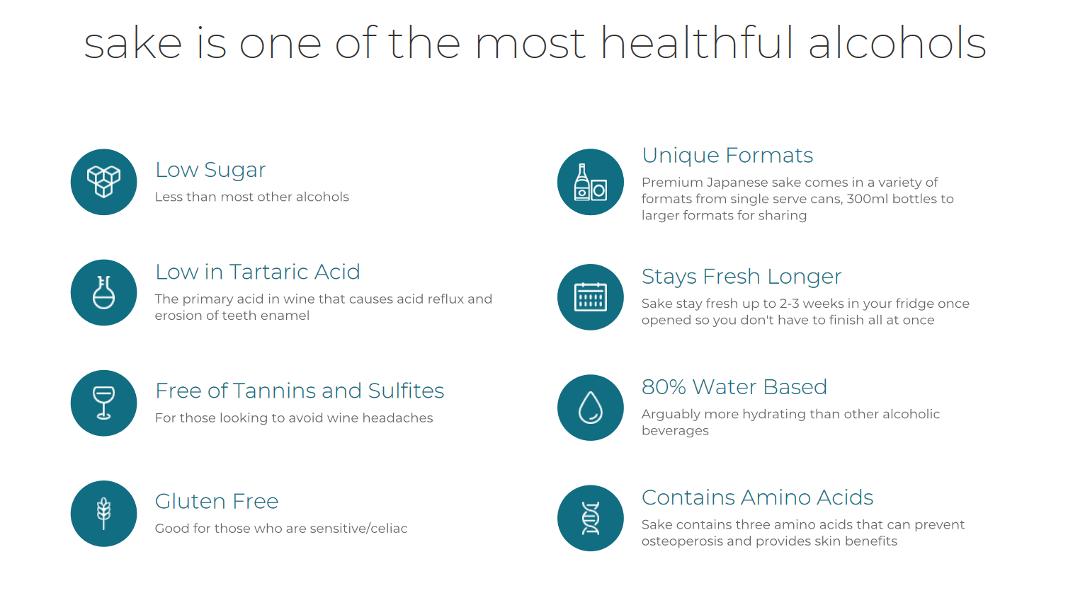

TERMS AND CONDITIONS OF SALE
MT Glass NZ Ltd supplies sakes subject to stock remaining on hand.
ORDERS & DELIVERY
Minimum is one case which may be mixed. Delivery is free to all customers within 30 kms of Greytown. All deliveries are undertaken either by our own van or by local courier. All orders received by 10.30am, are scheduled for delivery within 3 working days. Delivery charges may apply for emergency and weekend deliveries. Advice of non-delivery must be received in writing within 5 days of the invoice date; otherwise, MT Glass NZ Ltd cannot accept claims or responsibility for loss. Goods must be signed for legibly on receipt as either being in good condition or damaged and any such damage advised to us within 3 days.
NEW ACCOUNTS
Accounts requiring credit facilities are kindly requested to provide two trade references. Until satisfactory references are received, goods can be supplied on a pro-forma basis. TERMS, please note that, unless previously arranged otherwise, credit is limited to a maximum of $1000. Prices are quoted on Duty Paid Lists exclusive of GST. Cash / Direct credit/Eftpos is payable upon delivery unless a credit facility has been granted. For credit customers payment is to be within 25 days following delivery. MT Glass NZ Ltd reserves the right to pass all accounts that fall into arrears outside the normal Terms & Conditions (30 days from the invoice date) to a third party. We will add interest at a rate of 20% of the amount due.
FORCE MAJEURE
MT Glass NZ Ltd shall not be liable for any failure to fulfil any terms of any transaction governed by these conditions of sale if fulfilment has been delayed, hindered or prevented by any circumstances whatsoever which is not directly within their control.
RISK & TITLE
The goods shall be at the buyer’s risk from the moment of delivery. All goods remain the property of MT Glass NZ Ltd until payment in full has been received. Until such payment, the customer shall hold the goods and all items incorporating the goods as trustees for MT Glass NZ Ltd and must not remove, alter or deface any identification mark placed on the goods or their packaging by us. In the event of non-payment, MT Glass NZ Ltd shall be entitled, in addition to other rights, to enter any premises where goods may be and recover possession of them.
DATA PROTECTION ACT
To comply with the Act, MT Glass NZ Ltd is informs you that your name and address is recorded for the sole purpose of sending you its price lists, statements of account and any other information. Your name and address will not be given to any third party.
ORDERS ACCEPTED ONLY ON CUSTOMERS’ AGREEMENT TO THE ABOVE CONDITIONS

